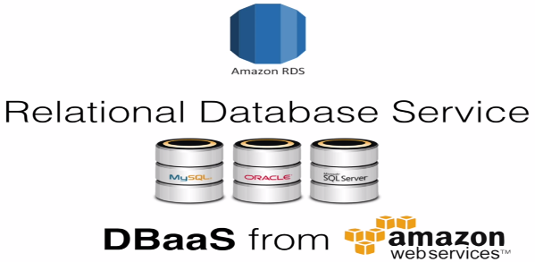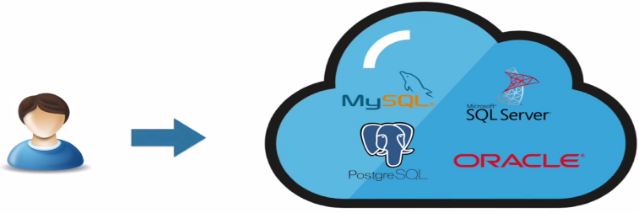

RDS is DBaaS(Database as a Service) from Amazon.

By launching RDS instance , we can get DB instance of our choice. Currently Amazon supports 6.

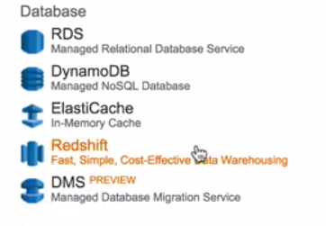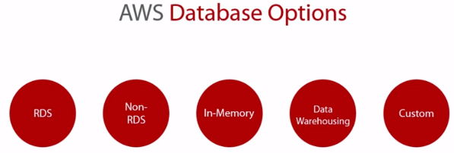

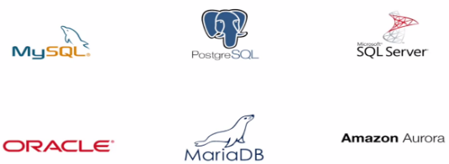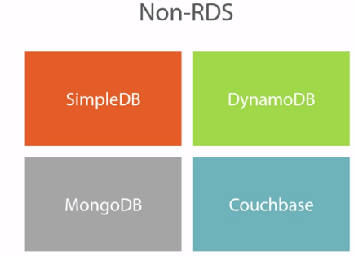

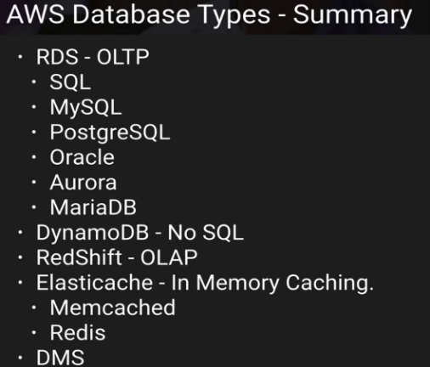

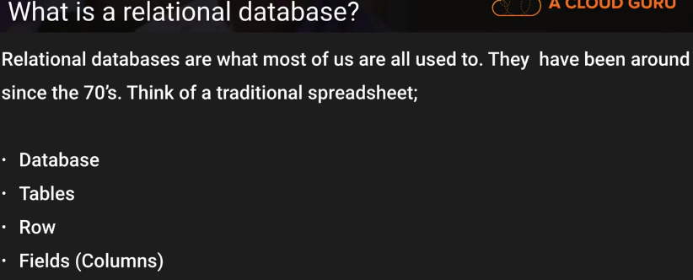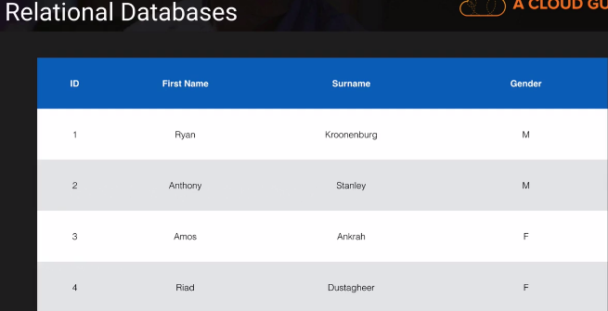

Row(Record)

Column🡪ID, FirstName, Surname, Gender.

Each filed have same type of data …first name(text), Surname(text),3rd (single character).

**Non-Relational:**

* Couche DB
* MangoDB.

In AWS, we use DynamoDB.

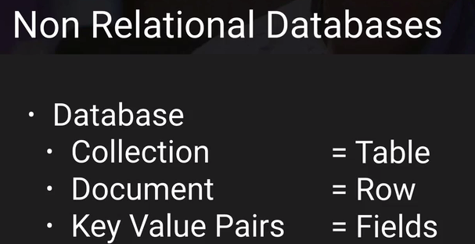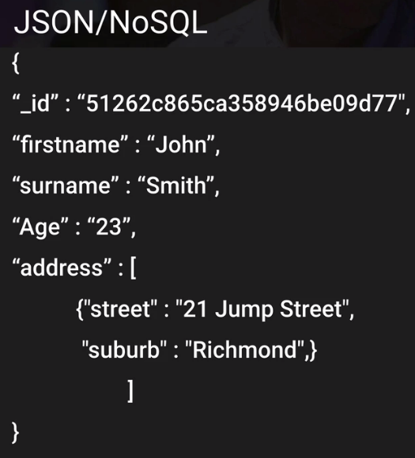

It is a document, which have different key-value pairs..

1st one: ID(512----)

2nd: firstname: John.

We can also have metadata structures like address, which have 2 key-value pairs.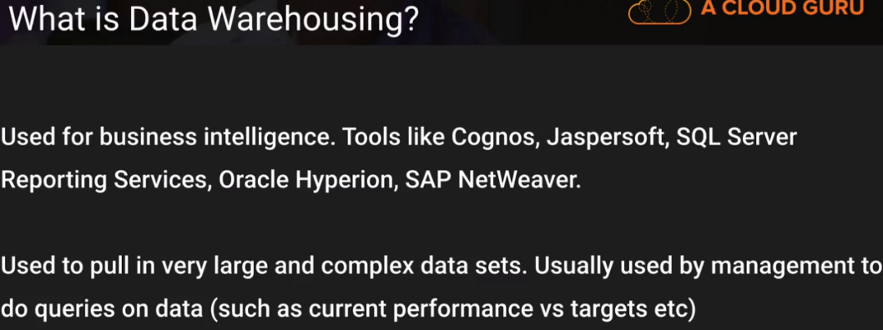

Lets see where we use Data Warehousing VS RDS.Different queries RUn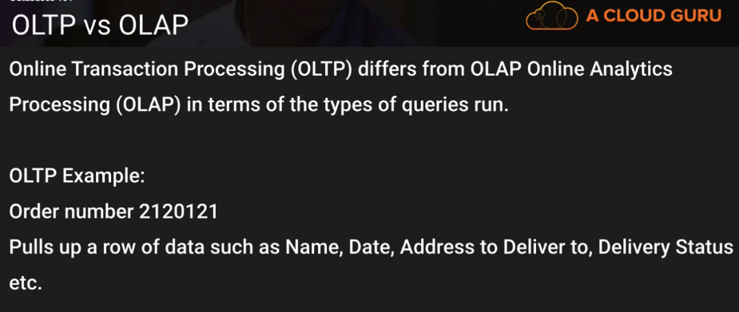

**Transactional:** select * ID=2120121.It can happen only once and hits DB very lightly.

**Analytics:**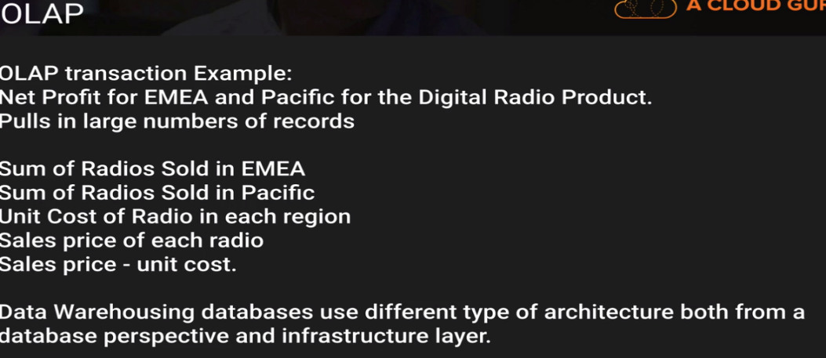

Analyze large volume of information.

Ex: Manager was asked to find net profit of particular product for a Digital radio product, which is for 12 months.

Amount of data involved is very large…And will be hitting DB very very hard.. Lot of different queries..

Relational DB are very difficult to scale out . If we are running these queries on Prod DB..will have effect on Customers failing transactions, and placing orders.

Data warehousing is more like a copy of Prod DB and 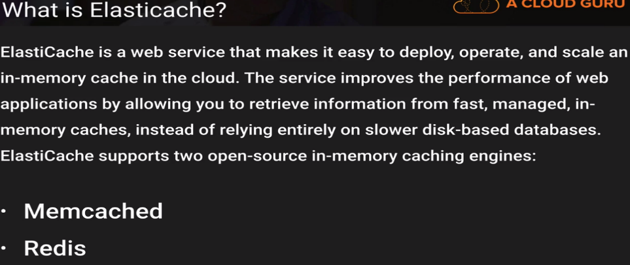

Elasticcache caches most consistently queried aspects of DB. Webapplication is constantly requesting for 10 deals of day.You might cache that info.So, web application will get info, from cache not from DB..

Just takes load of DB, and helps to improve basically performance of underlying DB.

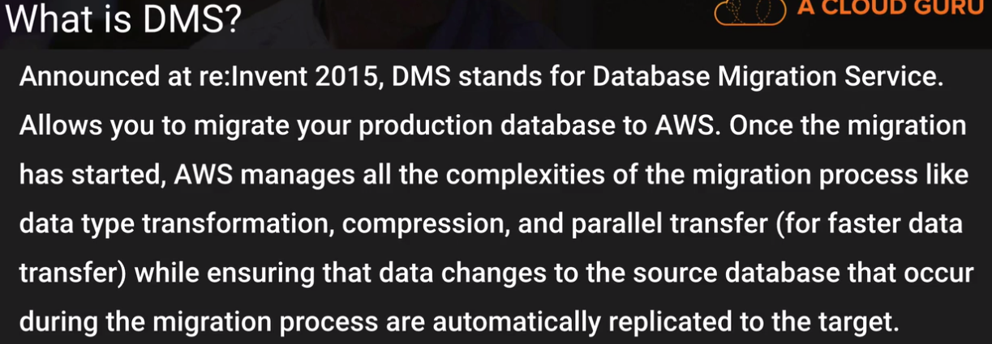

Whats important is: it helps to convert source DB to some target DB.

If we are using Legacy DB Oracle, which is extremely expensive in licensing. Most legacy applications use Orace.So what can be done??..We can use DMS and convert Oracle DB to Mysql DB for free or Alora.

It takes schemes, procedures, functions etc... and puts in a format that is compatible with Mysql..

**RDS**

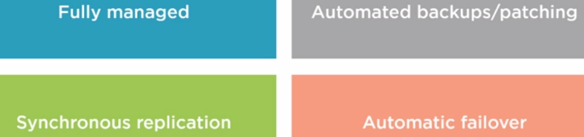

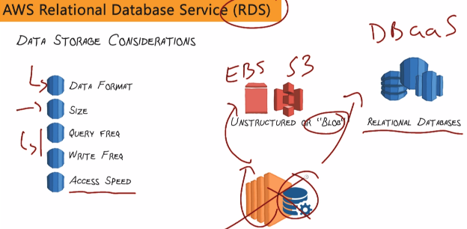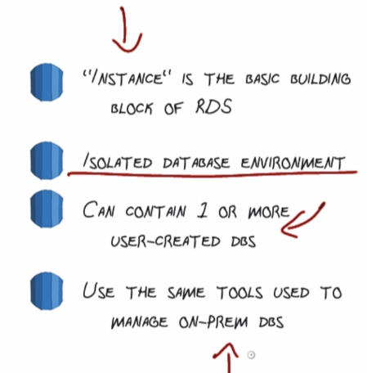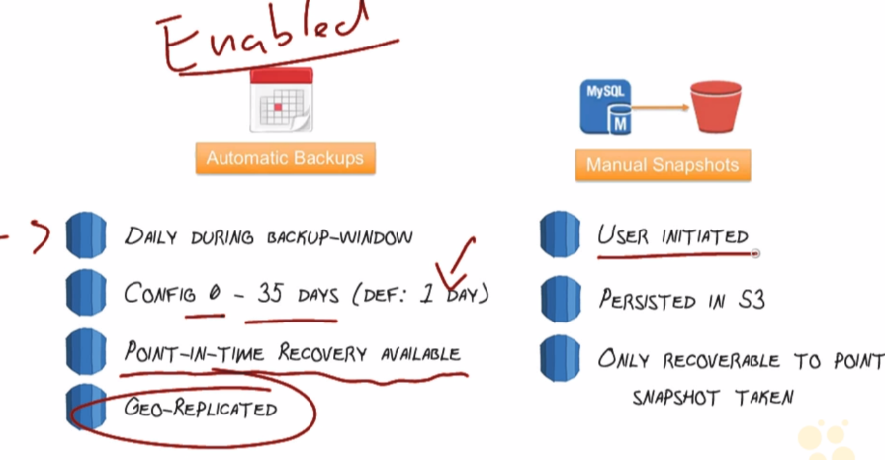

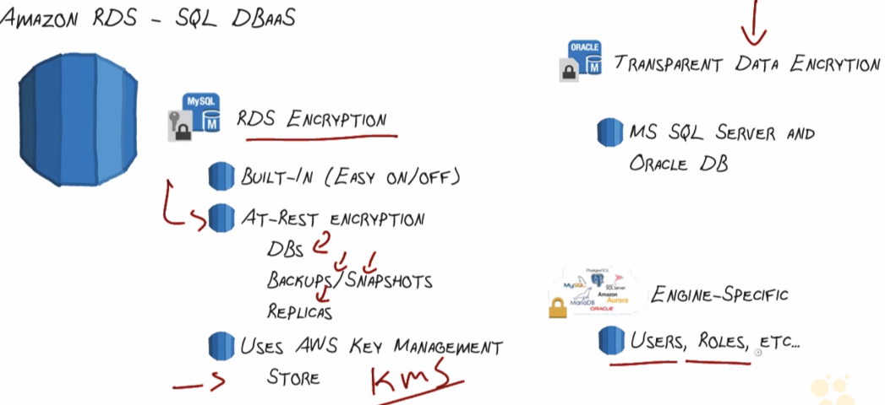

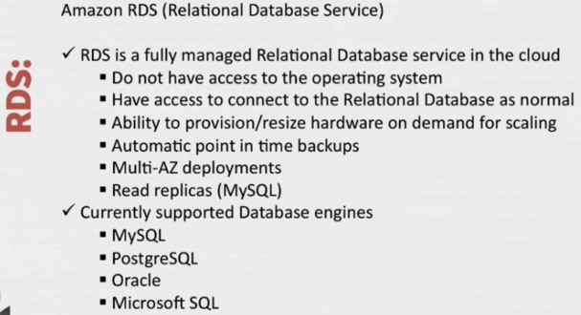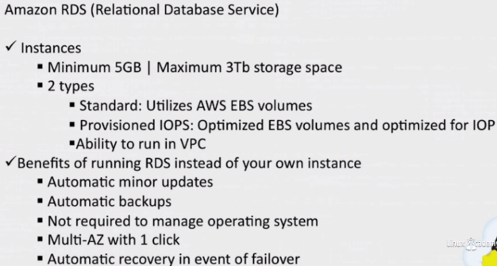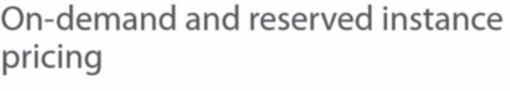

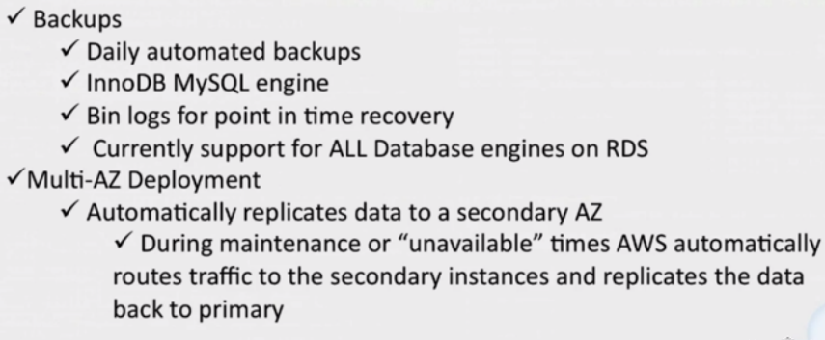

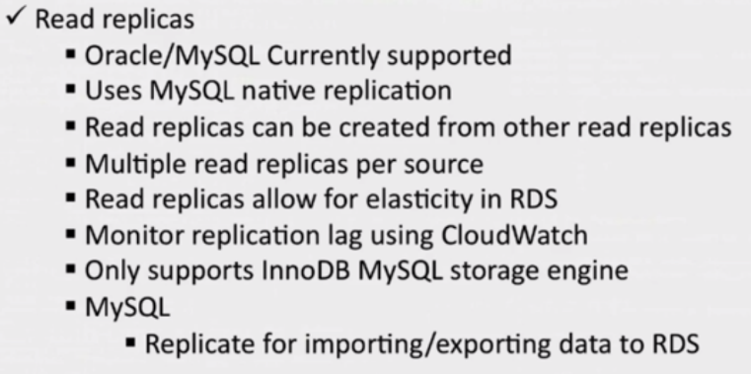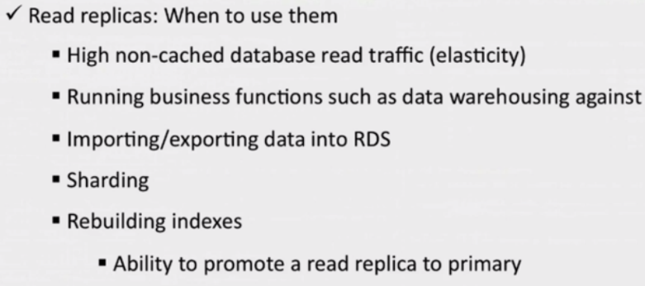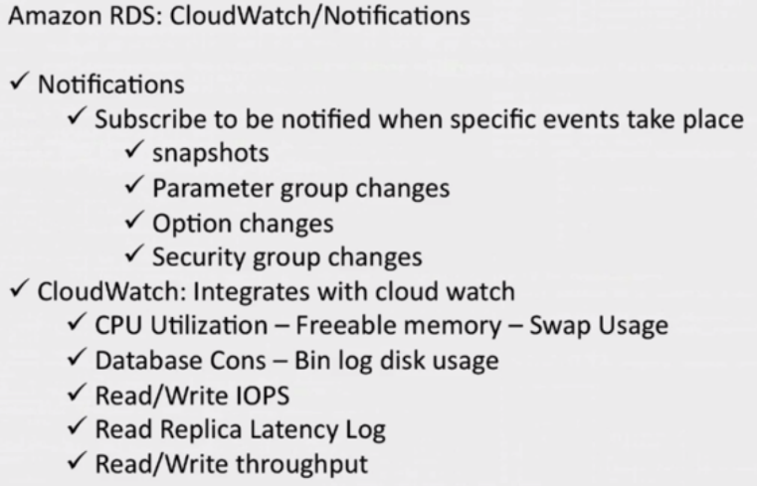

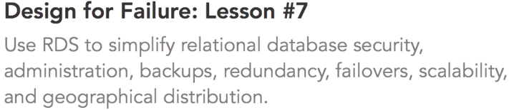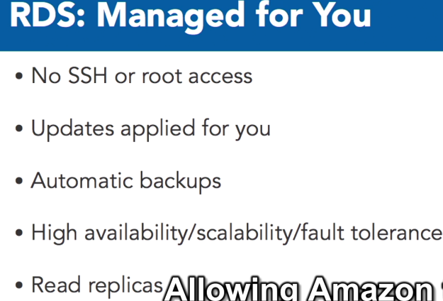

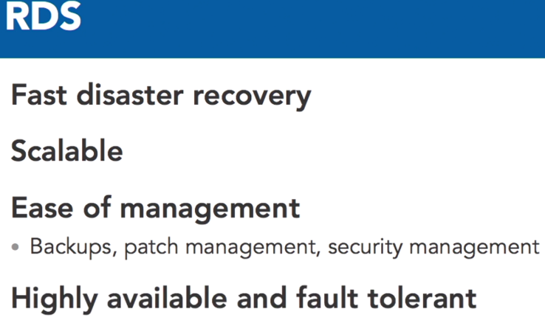

**31_-_RDS_Security_Groups**

***GOTO EC2:***

1. 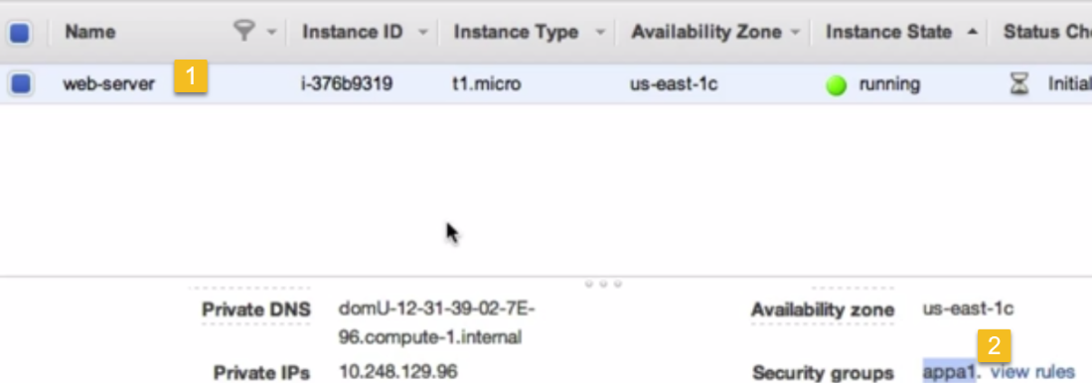
2. 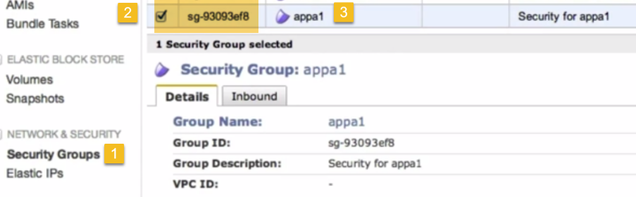**(copy security group of appa1)**

**GOTO RDS**

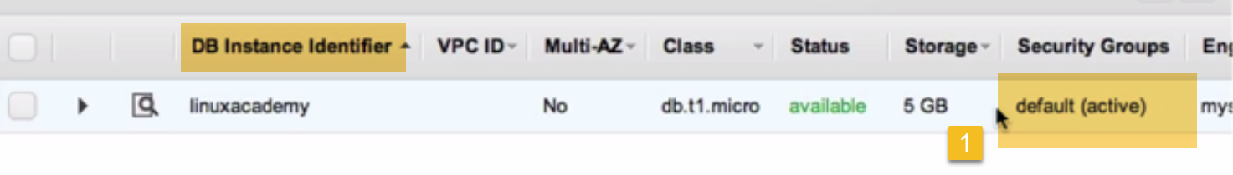

**RDS is in default Security group**

**Now, DB instance and Ec2 instance cannot communicate with eachother**

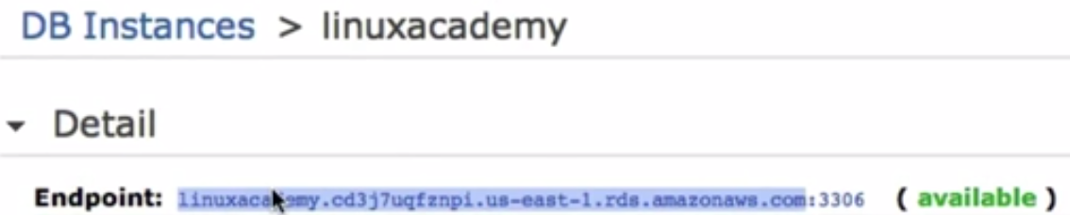

1. **On EC2 instance**



**Fails because we are not allowed access in Security group.**

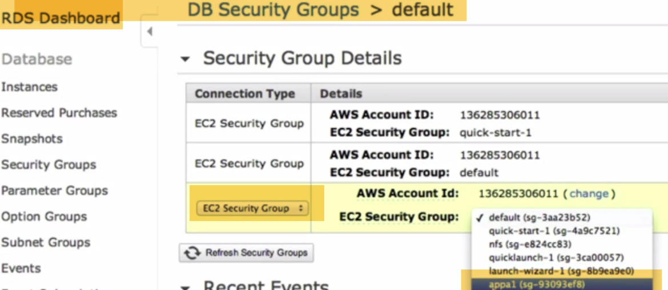

**On RDS Security group, Select EC2 security group-🡪Select appa1(security group of EC2 Instance)**

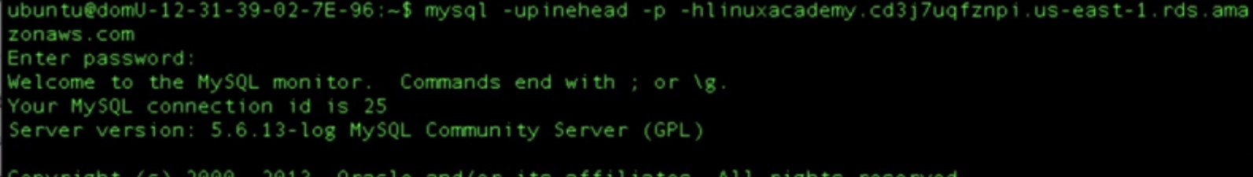

1. **FROM LOCAL PC(any)**



**Fails..Because we there isn’t added any security group**

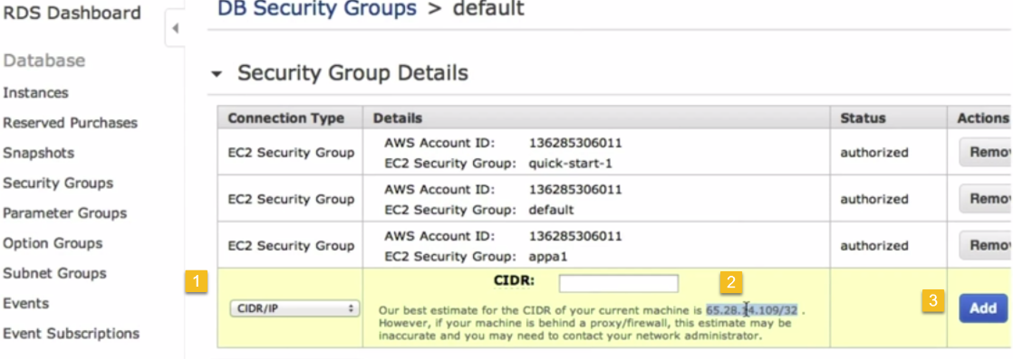

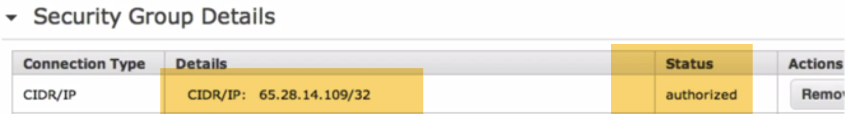

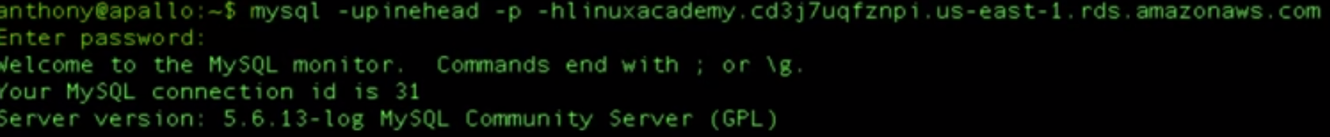

**64 - Launching an RDS Instance - Lab**

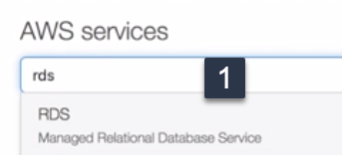

Takes to RDS homepage

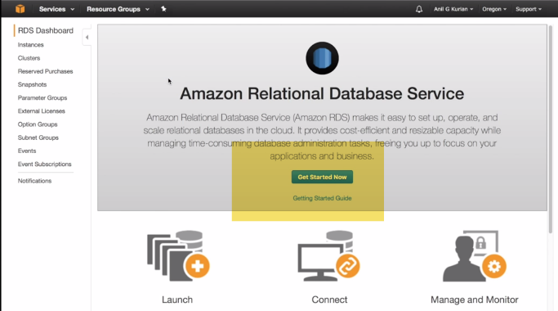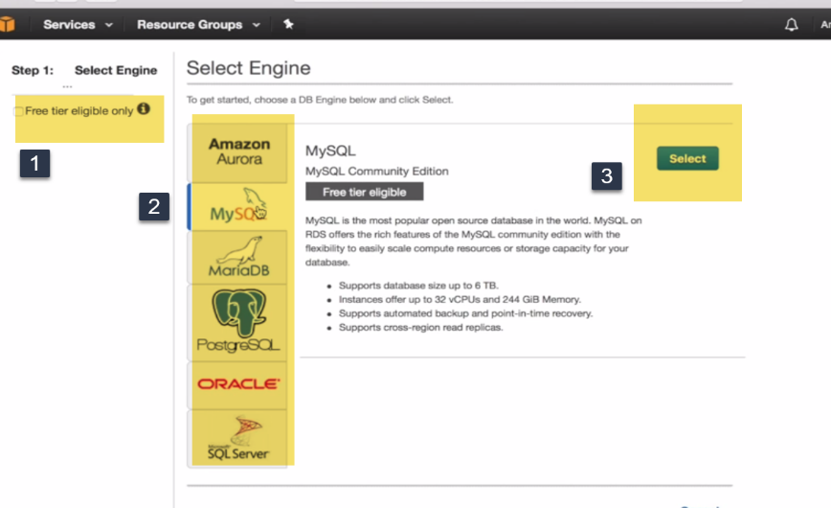

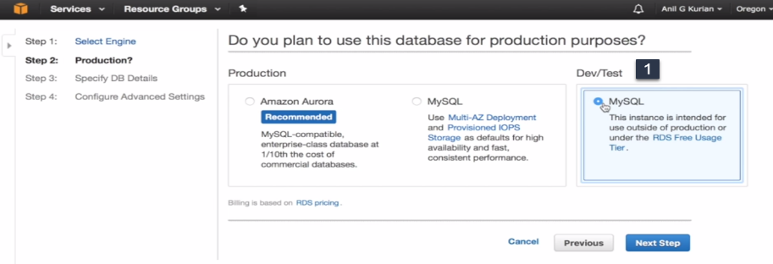(for free-tier use mydql Dev/Test)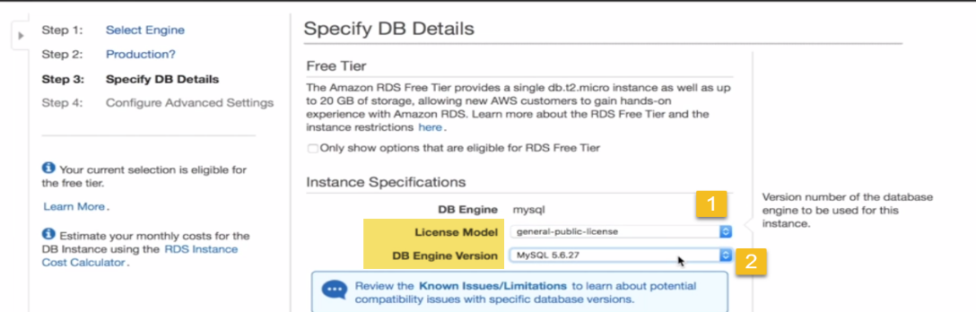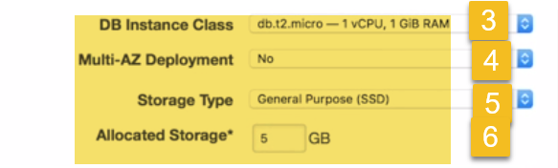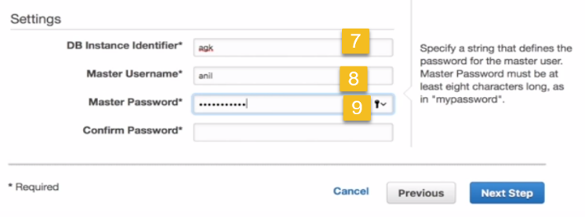

**License:** General public license

**DB Engine version:**

**Instance class:** db.t2.micro -1 vcpu,1 GB RAM

**Multi A-Z Deployment:**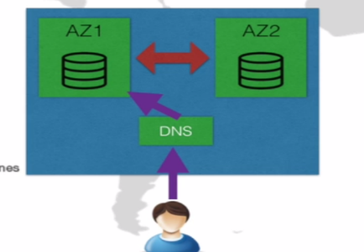 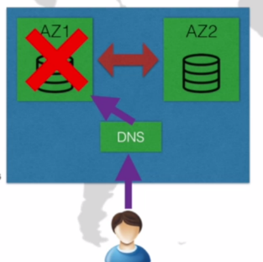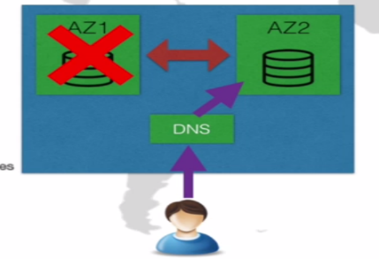

AWS Setup replication of DB to another AZ. In case of failure at primary, DB will be automatically switched to another region.

**Storage Class:** General SSD, Provisional SSD (Better IOPS), Magnetic

**Storage:**

**Master Instance Identifier:** Name that is unique for all DB instances owned by your AWS a/c in current region.

**Master Username:**

**Master Password:**

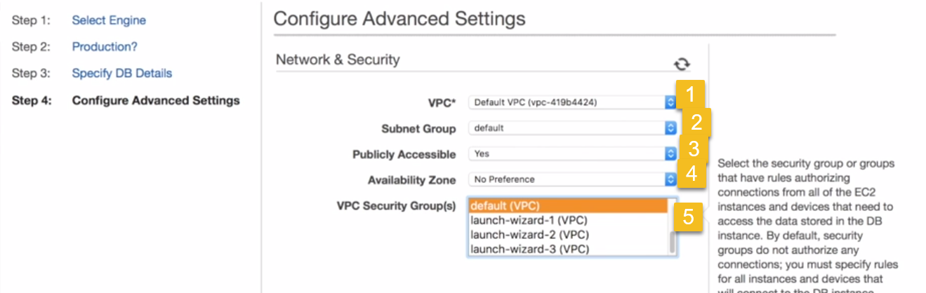

Publicly Accessible: 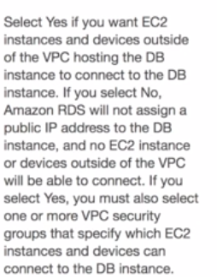

**AZ:** EC2 AZ, where DB is to be created. AWS will pick one, which is least loaded

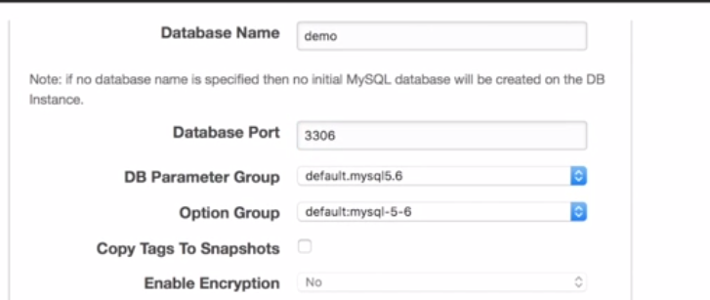

Create Database(optional) , port

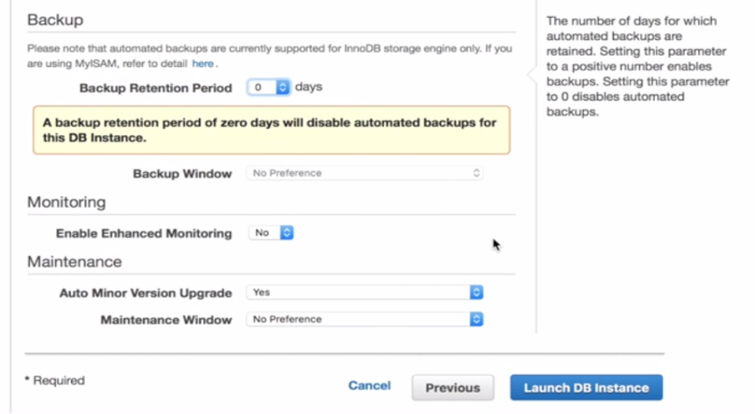

**Retention:** By Default, AWS keeps backup for 7 days..(0-🡪 No backup needed).

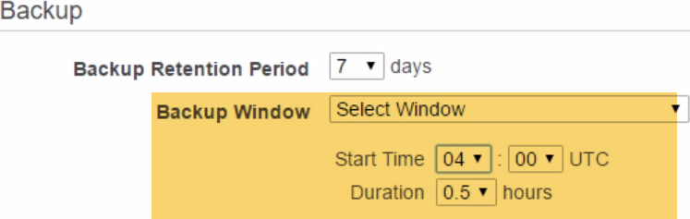

We can select DB backup Window.. So it will not effect Users..

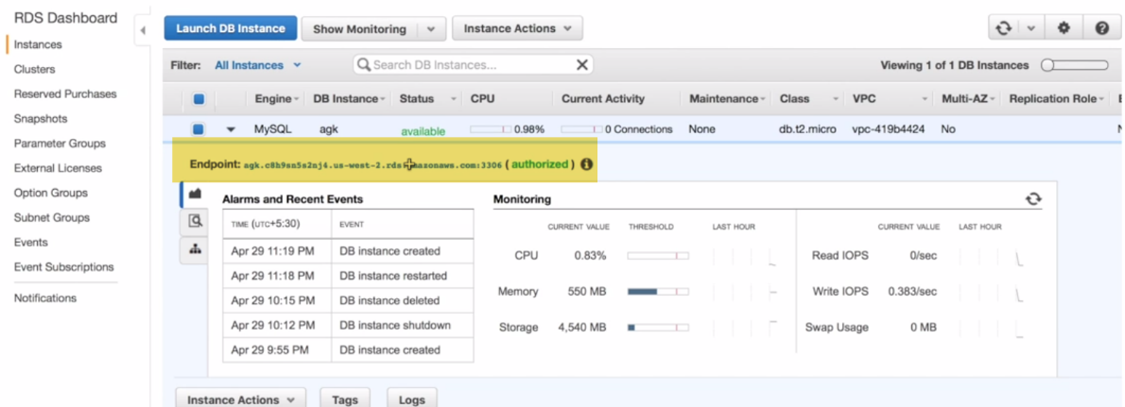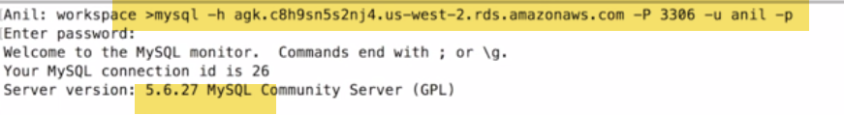

**Configure Security Groups:** 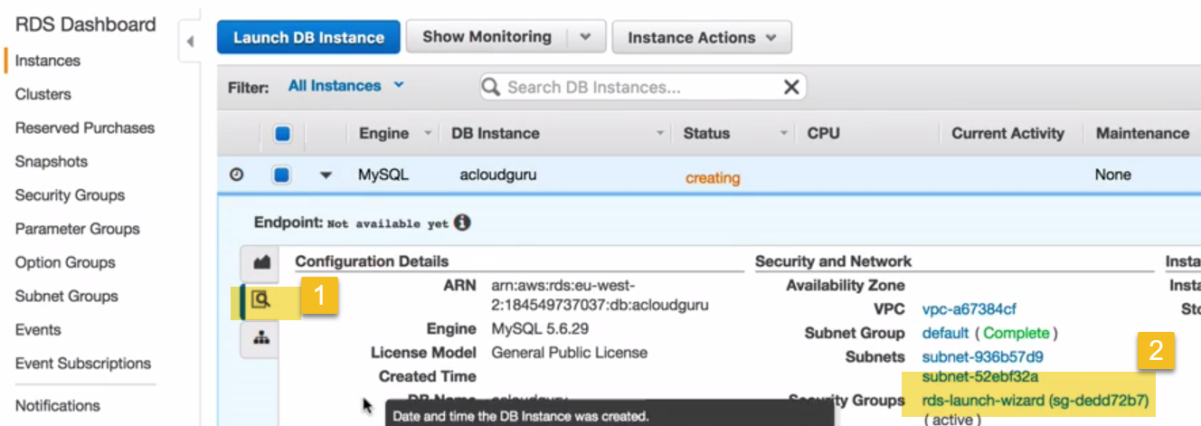

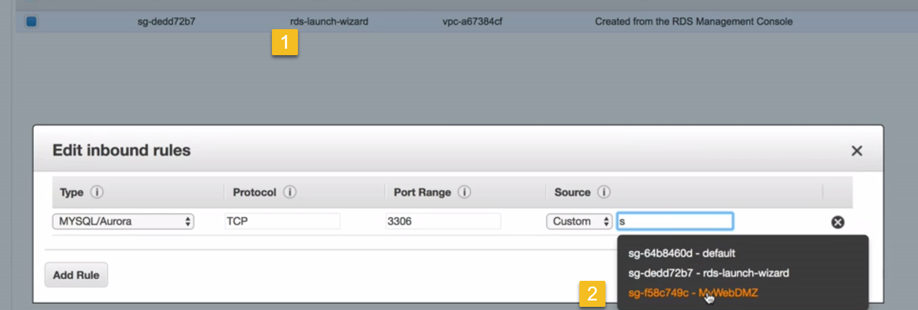

We can configure security group---custom to be from Security group instance access.

**Launch EC2 instanc**

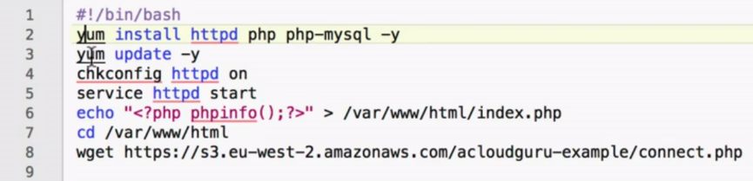

We are creating a index file index.php, outputting contents of webpage..

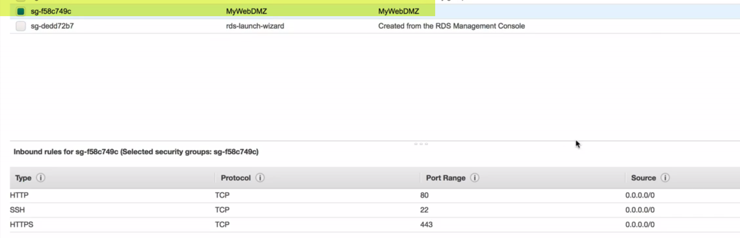

RDS security group will communicate with web security group over port 3306.

RDS-launch allows traffic from MyWebDMZ

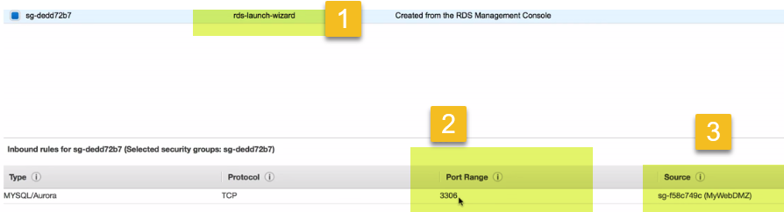

RDS-llaunch allows traffic from security group

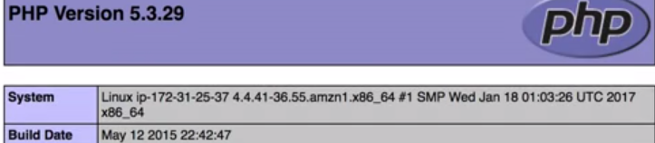

**This is PHPInfo Page**

 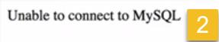





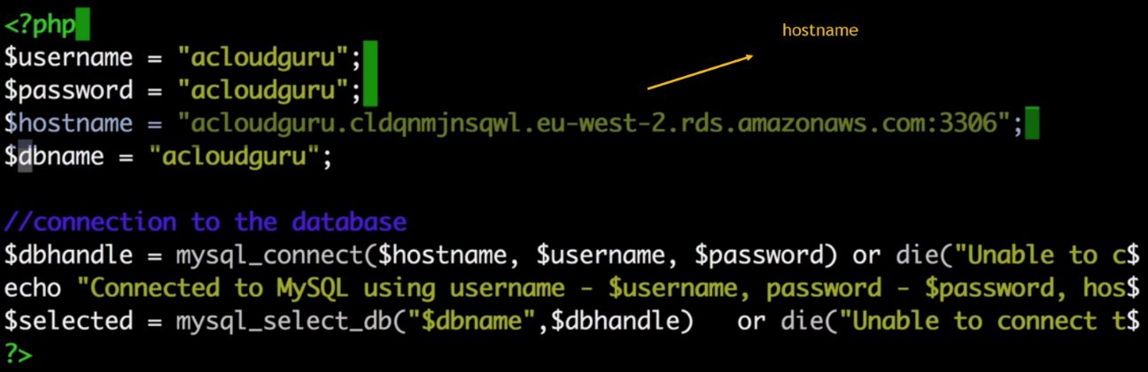

Change hostname in connect.php file



RDS isn’t public and going through security groups

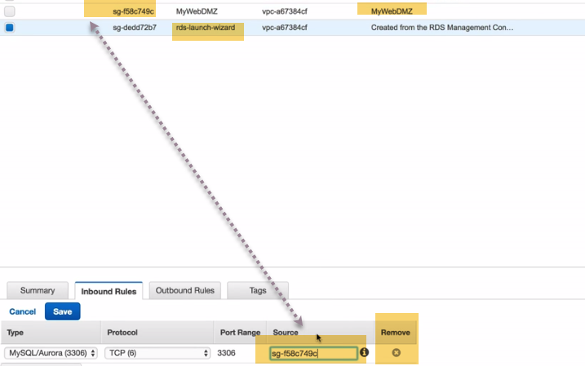

Goto security group of rds launch and remove this rule

Cannot load page..

Always check to allow port 3306 in RDS security group and actually trust webDMZ security group..

Always have 2 security groups..1 for instance ..1 for RDS.

Allow RDS port 3306 through RDS instance from webservice group..

**Delete:**

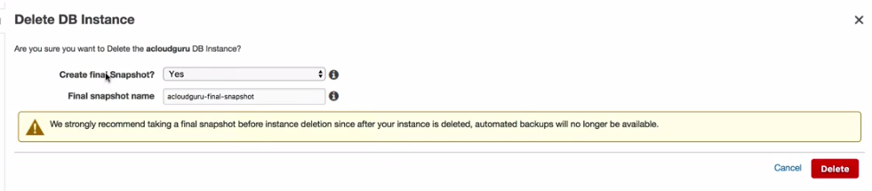

1. **FOR PRIVATE SUBNET**

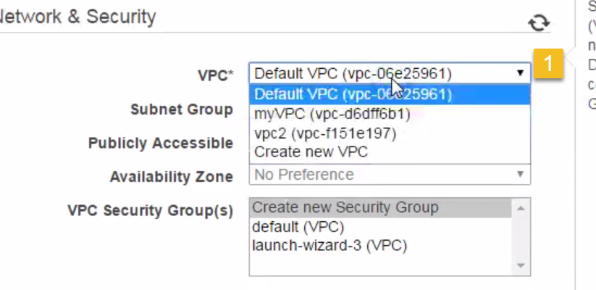

**We keep DB in private subnet, because we don’t want DB to be accessible from intenet.**

1. **AD authentication.**

If I have an EC2 instance running on Windows Domain Controller, I can hook this DB.I can use windows authentication from DC to autjenticate users for DC( Feature available only on Microsoft SQL server)..

Also, We need to Select VPC on Domain Controller..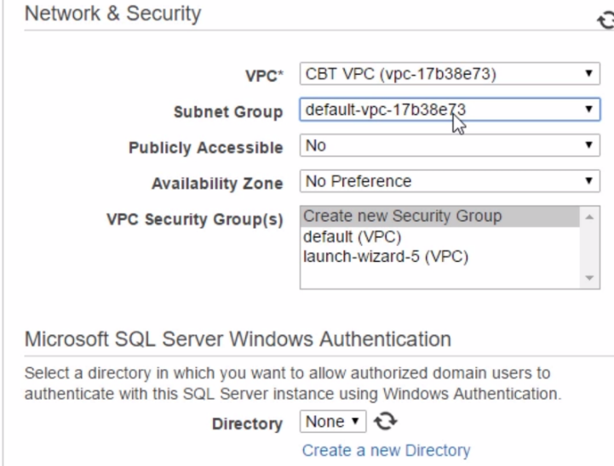

**Only APP server(EC2 instance) communicates with DB server.**

VPC ,Subnet, Security Groups

**065 Scalability with RDS Read Replicas - Part 01**

**12-79-1 - Read Replicas with MySQL RDS Across Regions**

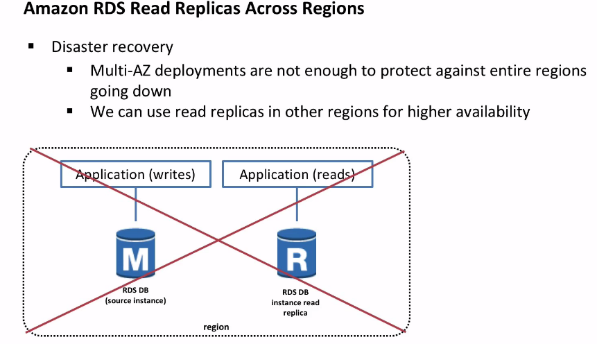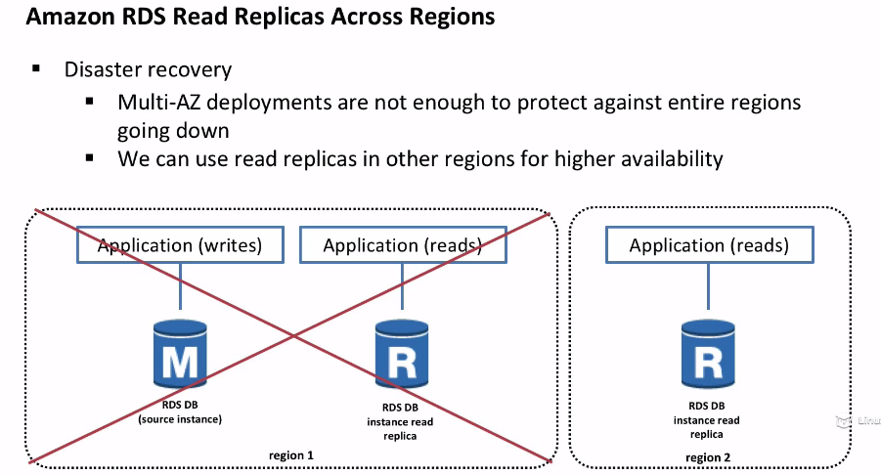

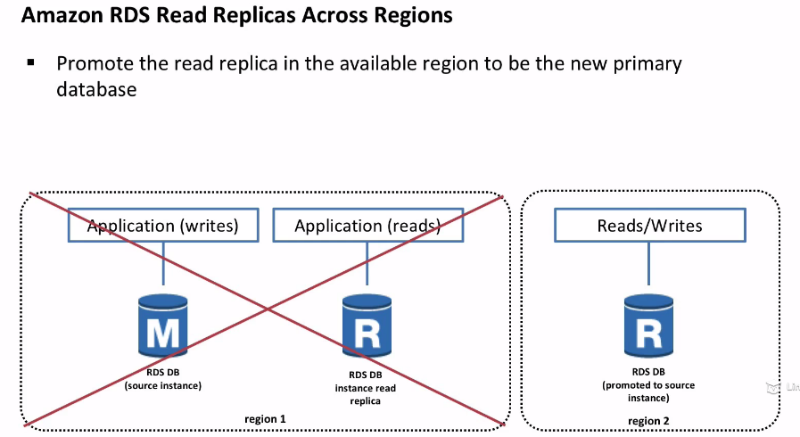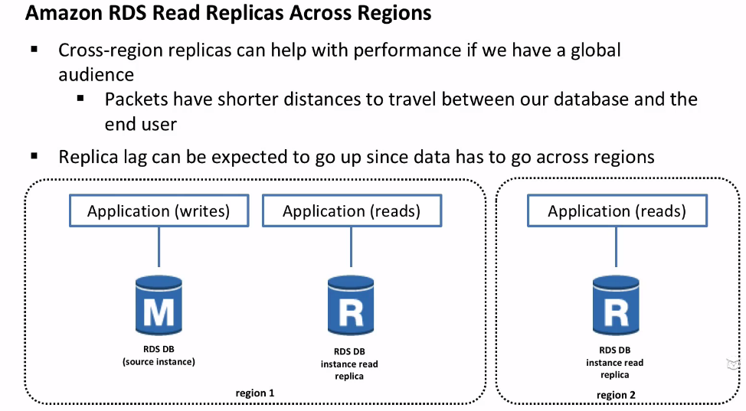

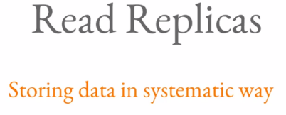

When organization is growing. This might be needed to implement

Typically in Indian bank for different work we need to approach different people.The reason for this is :If number of persons increased at bank..And only a person is doung all theses activities.The amount of work(load) is increased .So there is distribution of work happens.

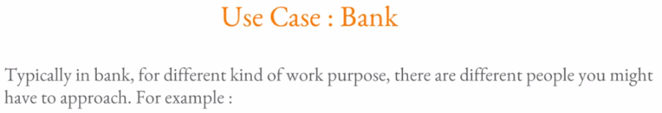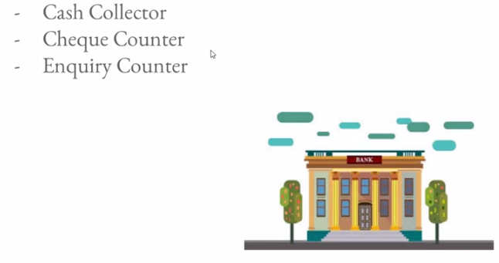

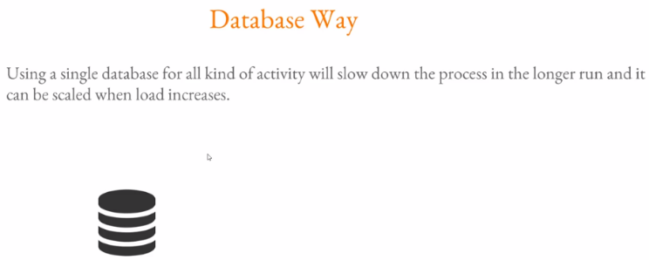

Similarly if we use single DB for all kinds of activity, and specifically when number of persons increases it will slow down entire DB. If sB is slow, it will slow down entire website. **Hence relying on Single DB is not good option, when we want to scale out.**

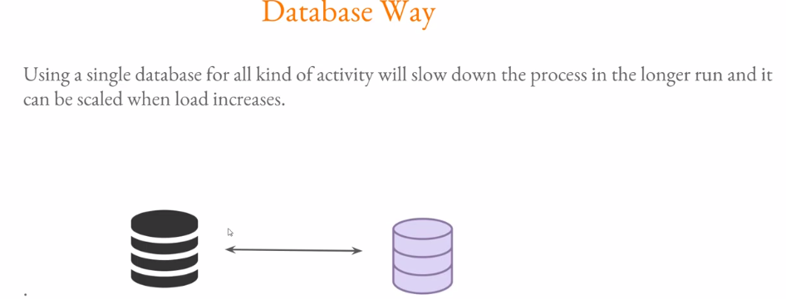

Let say we have multiple DB. Black(master) and 2nd DB are in sync.

Whenever these is change, it will get synchronized with 2nd DB. Once both DBs are in sync in terms of data…**We can optimize how query is sent to each and every DBs.**

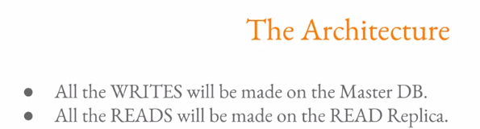

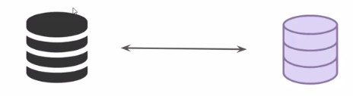

Lets assume black is primary DB, and load is increasing a lot. We don’t want to increase size of DB every one month.

**So, we have to do horizontal scaling instead of vertical Scaling.**

**horizontal scaling:** In this, we create one more DB, and create sync b/w both of them.SO data in 1st Db will be replicated in 2nd DB as well. Once data is in Sync, What to do is:

Lets assume computer is application or query.

All write queries can be send to Master Db and read DB to 2nd art DB.

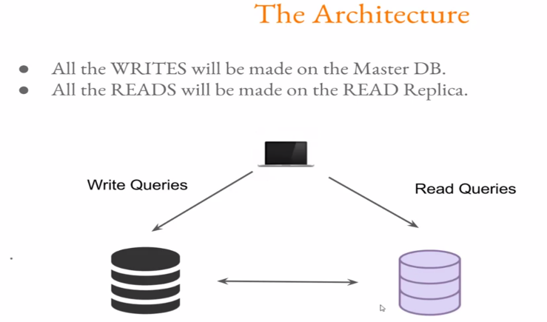

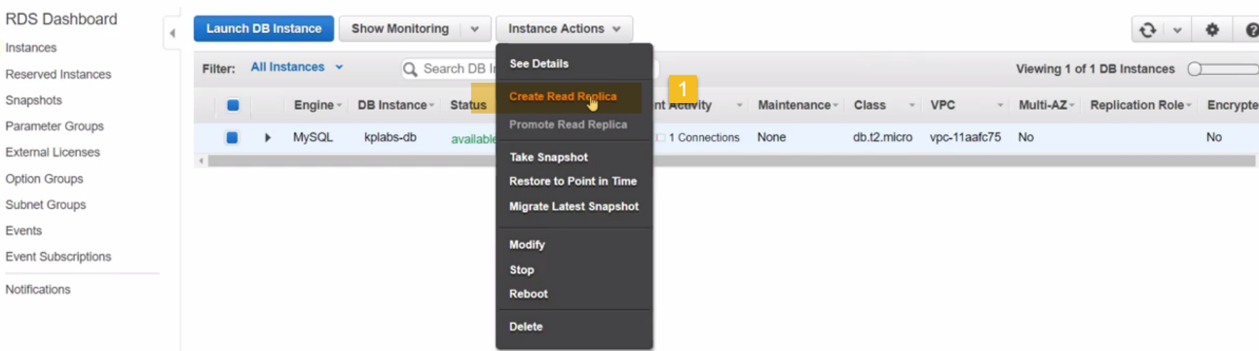

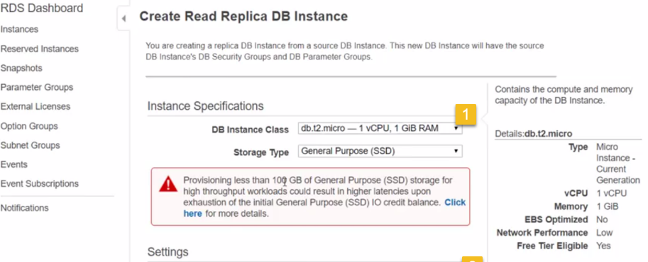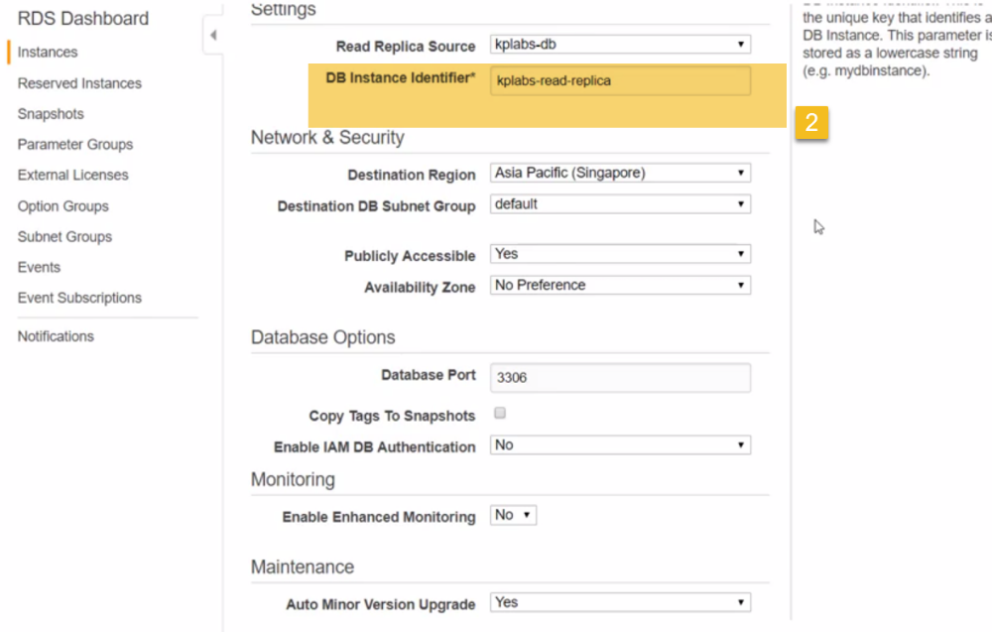

**066 Implementing Analyzing RDS Read Replicas - Part 02**

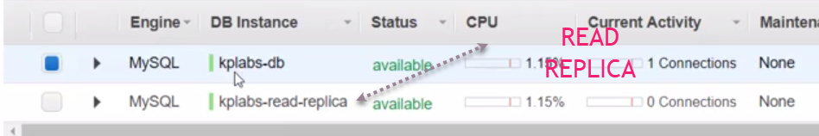

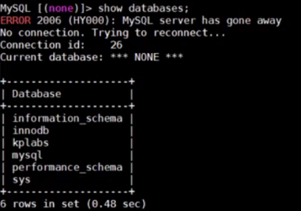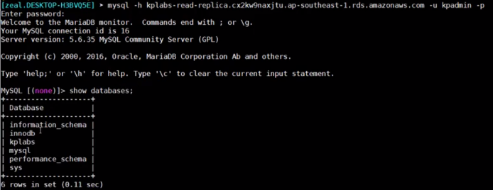

**2.)Create DB in master**

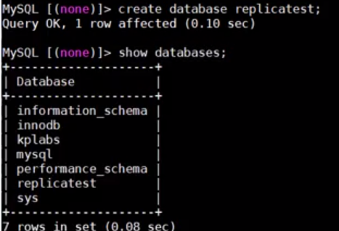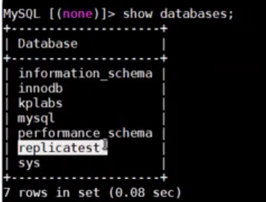

**It is replicated to 2nd DB as well**

**(On replica)**

**3.) On replica do:**

**4.)** 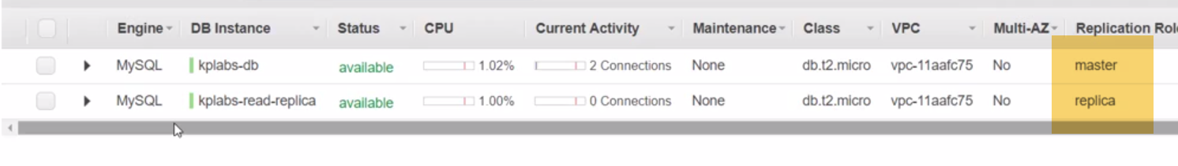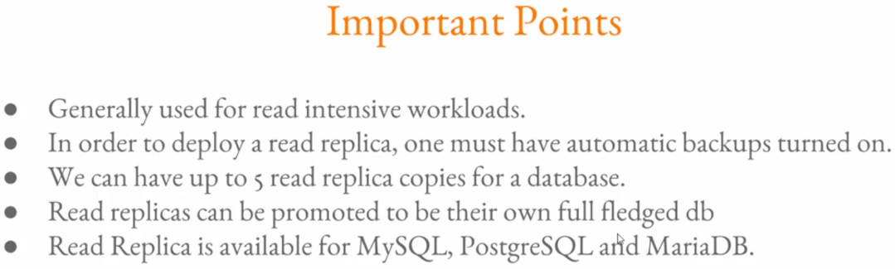

**high-availability-elasticity-aws-certified-devops-engineer-m4-04 - Vertical and Horizontal Scale with Amazon RDS - Implementing Scalable and Highly Available Datab.mp4**

**ScaleUp Instance Type:**

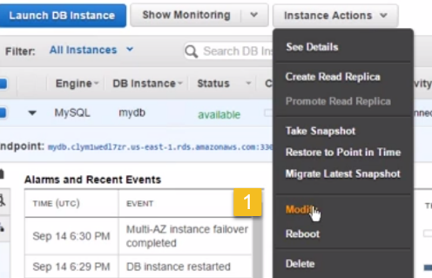

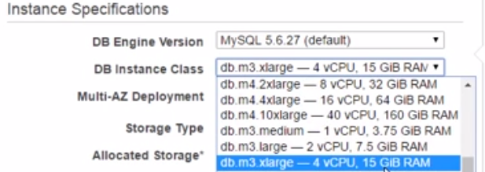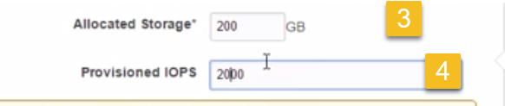

**READ Replica in another region:**

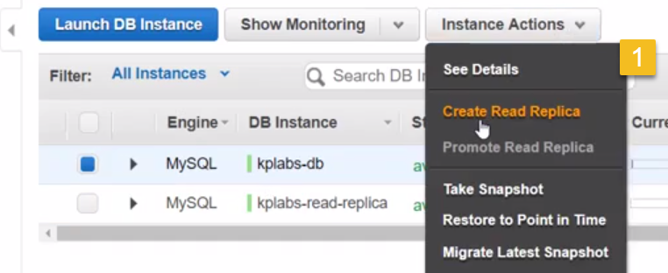

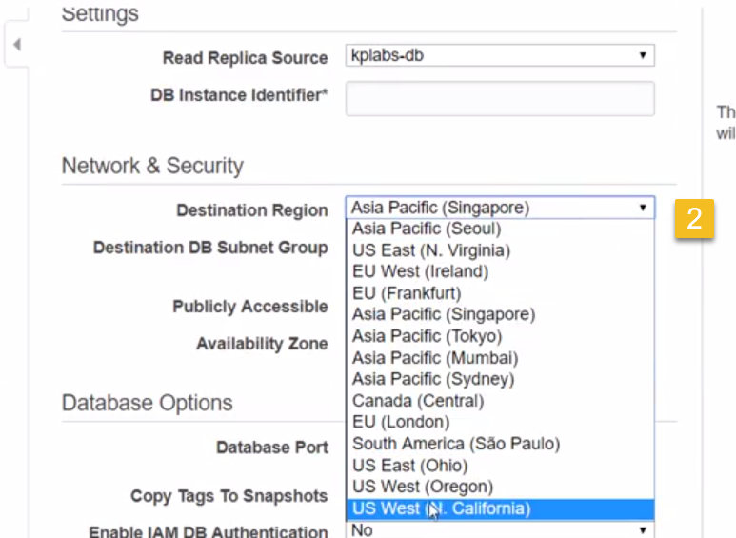

**Promote Read Replica to be Stand-alone Server:**

**Monitoring** 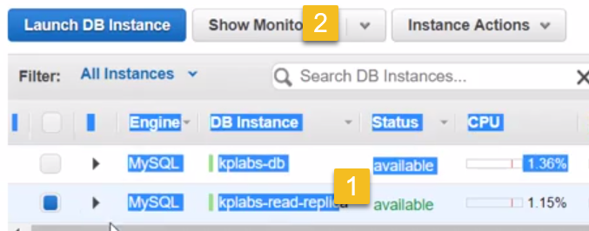

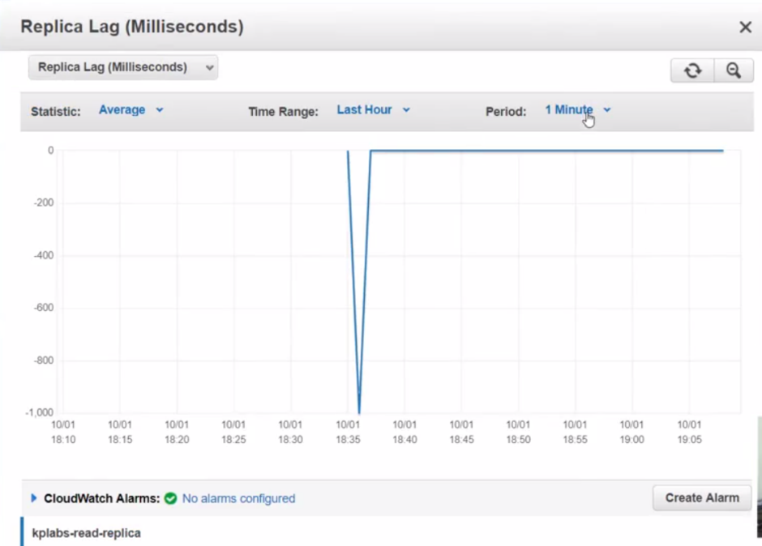

When RDS is concerned, WRITE will be done on master first. And then replica will be sent on replica server...

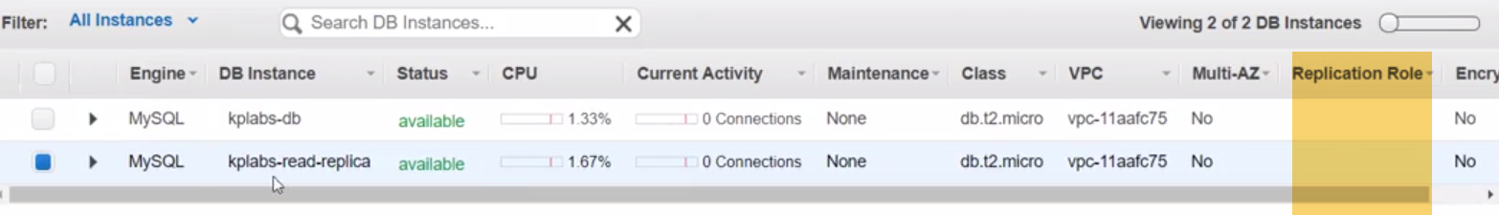

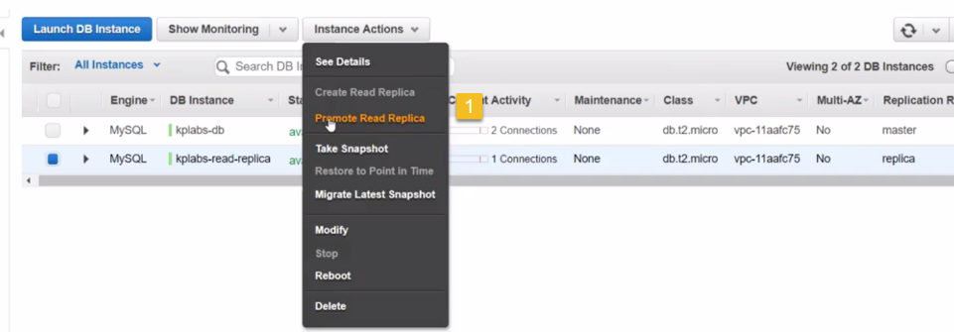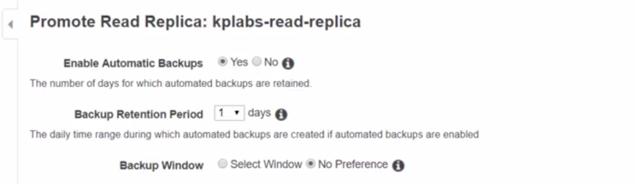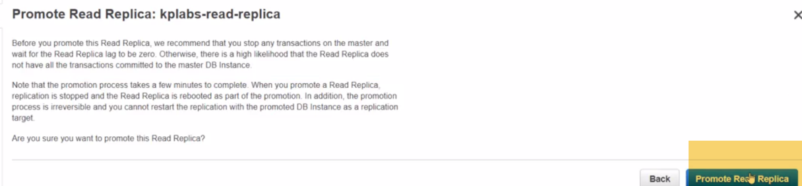

Connect to read replica server.

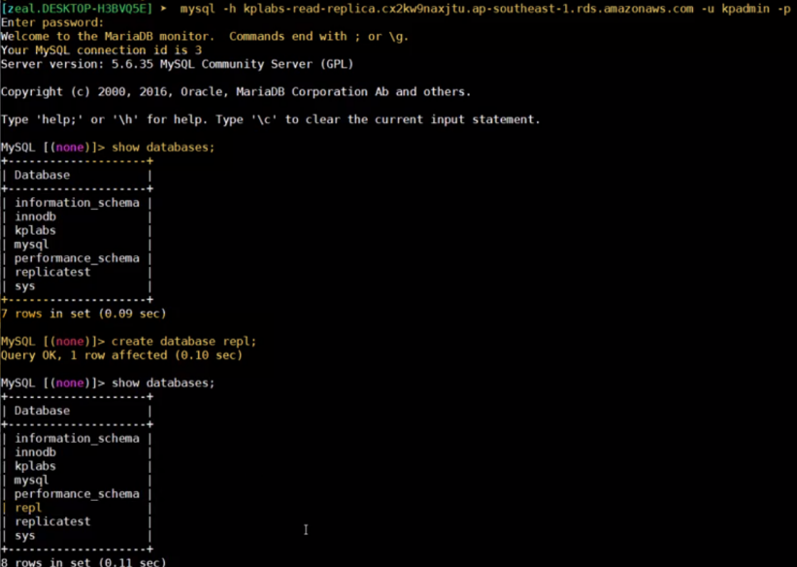

**067 Automatic Failover with RDS Multi-AZ Deployments:**

**aws-certified-sysops-admin-associate-m16-02 - RDS Characteristics - RDS HA and Load Sharing.mp4**

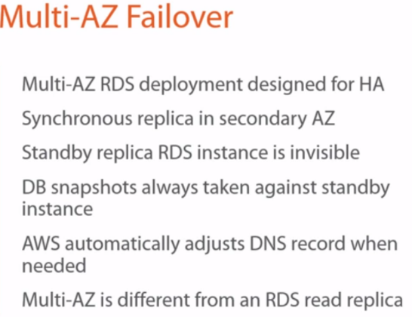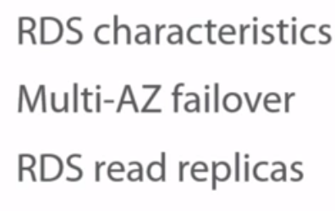

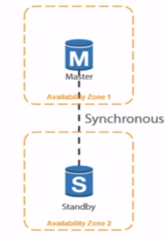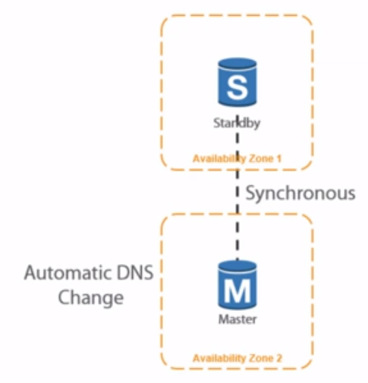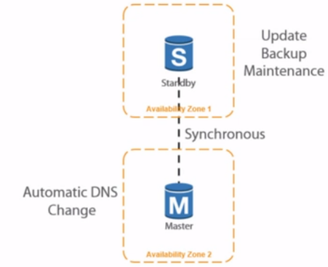

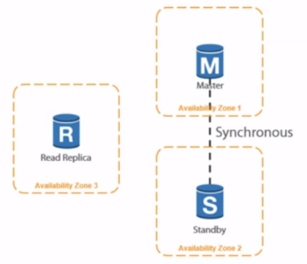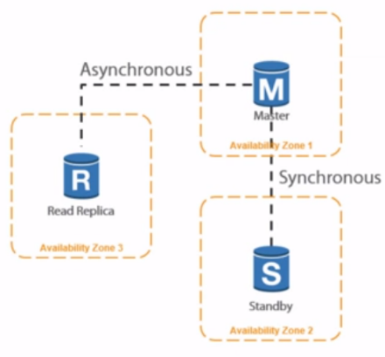

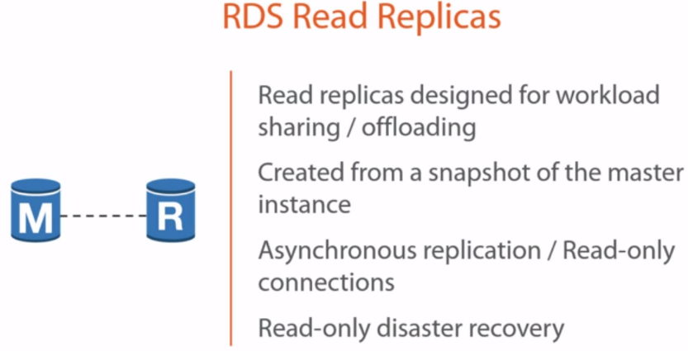

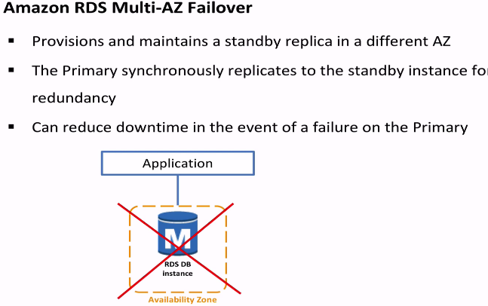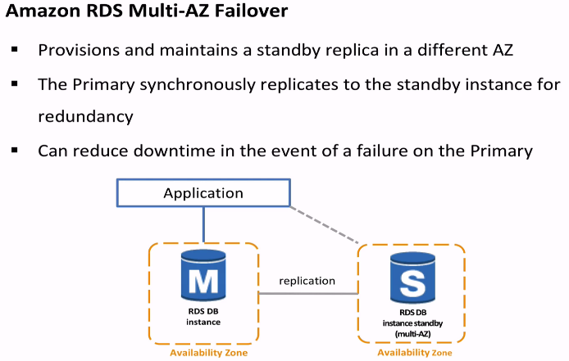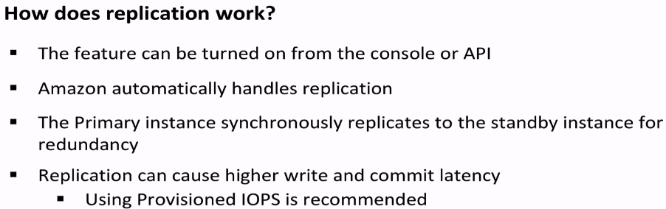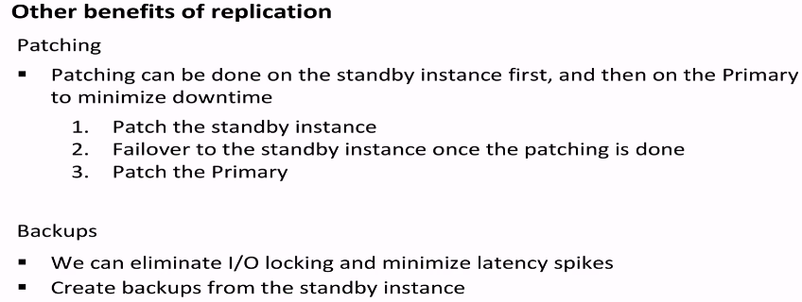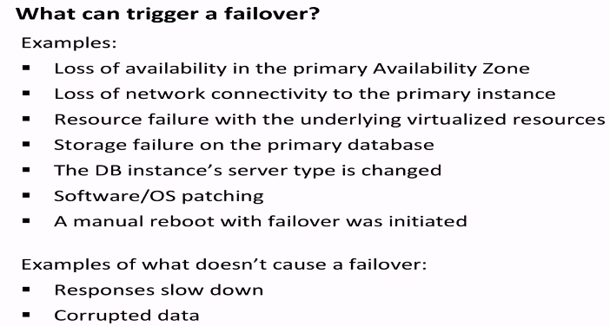

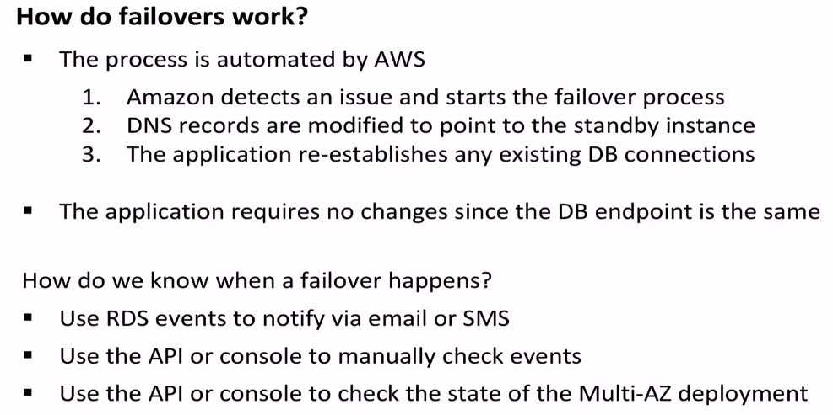

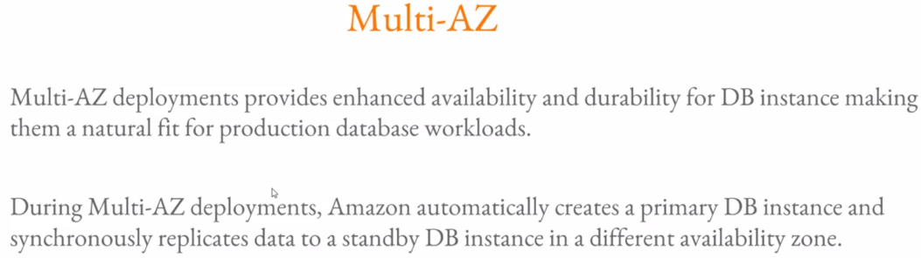



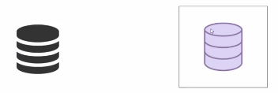 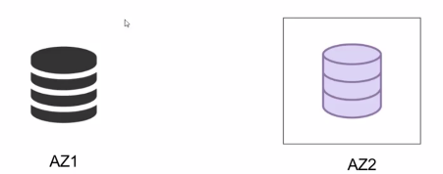 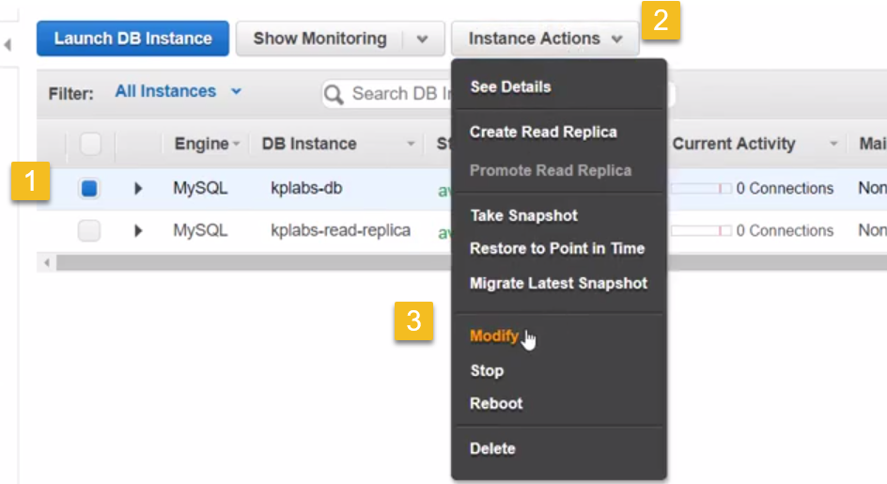 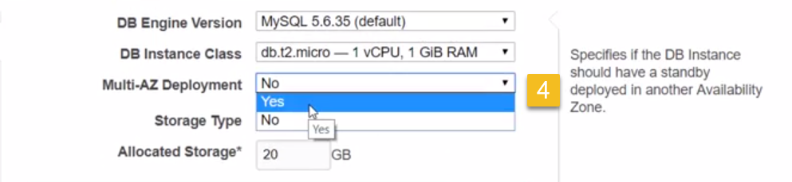 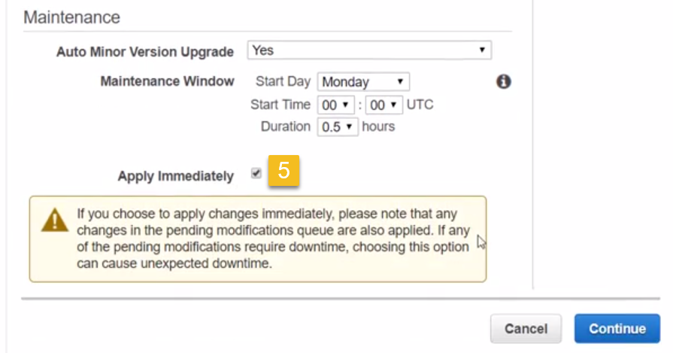 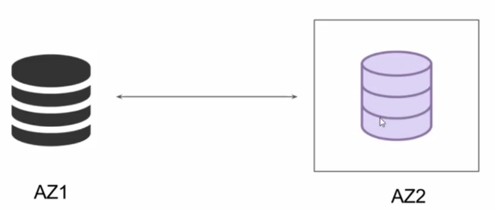

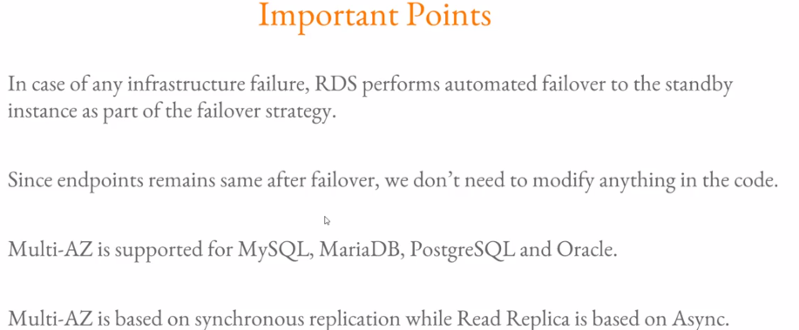

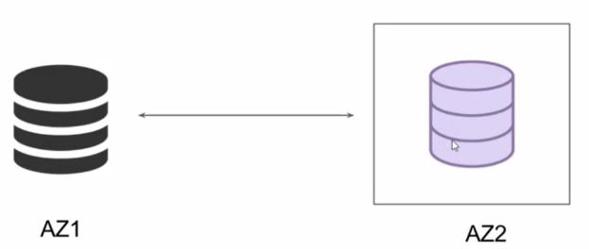

**RDS Backup Options - Understanding Backup Options.mp4**

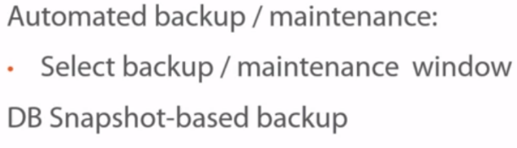

**12-177-7 - Monitoring RDS for Performance and Availability**

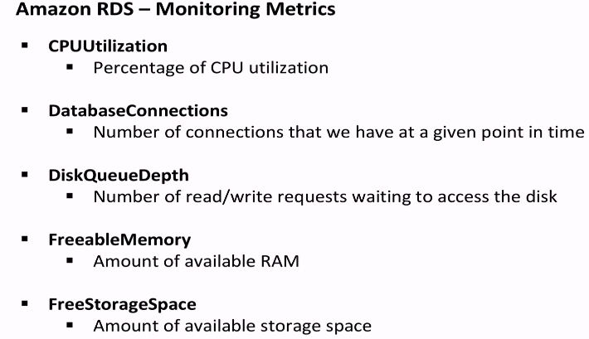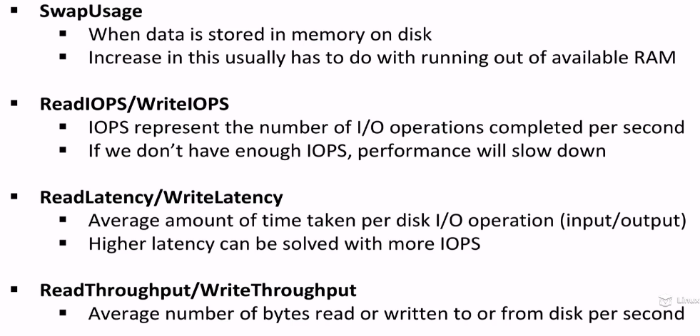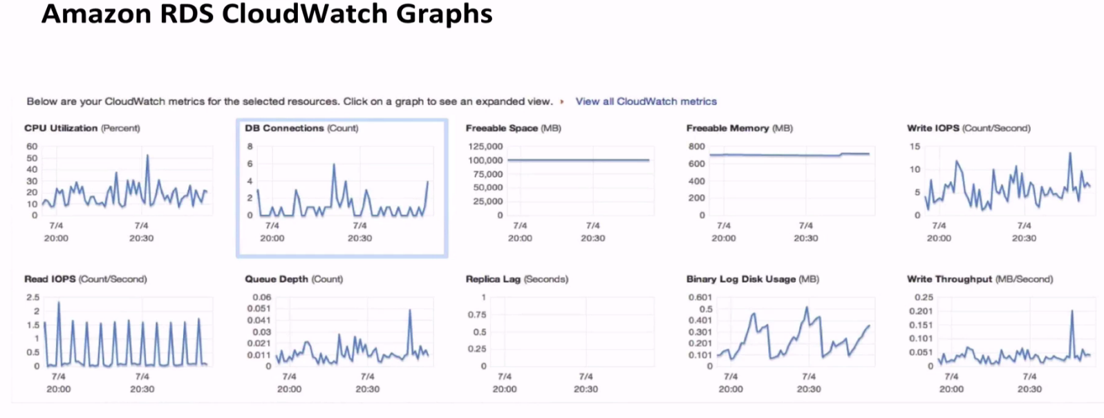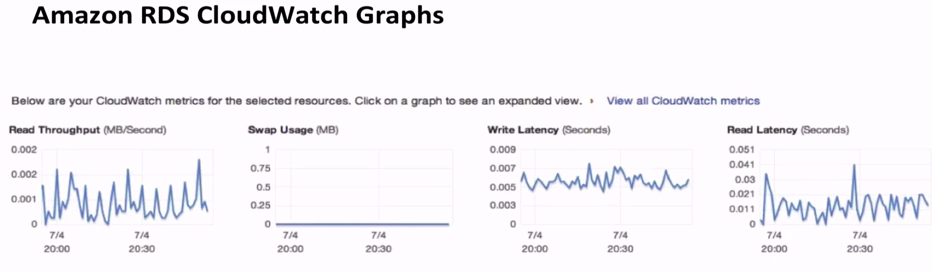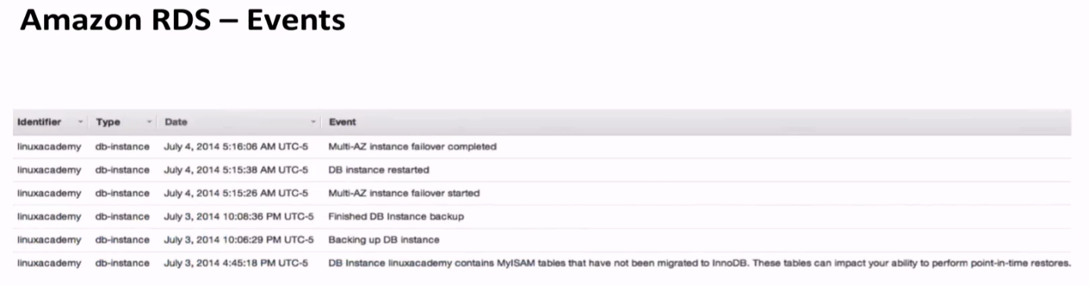

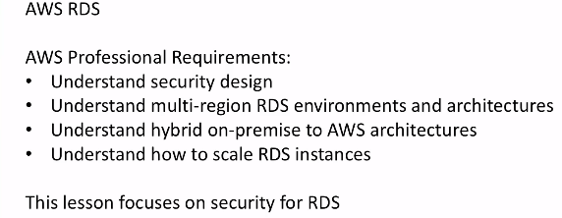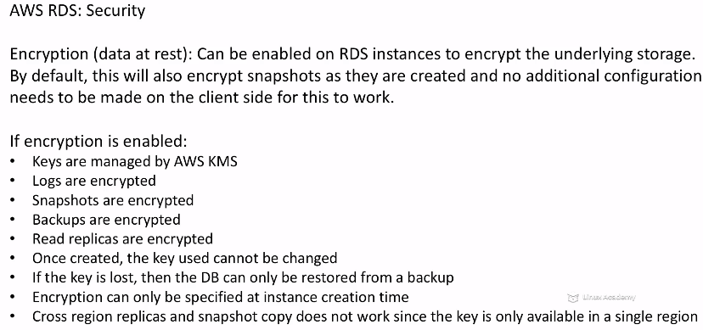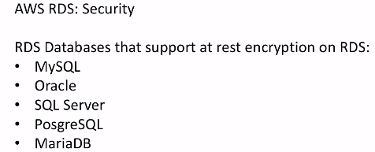

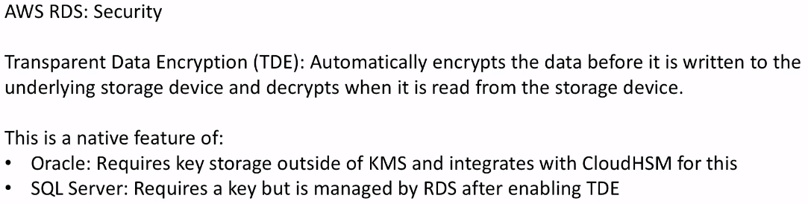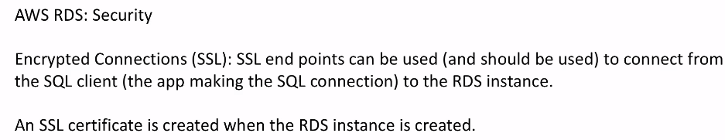

**2 - MySQL and MariaDB on RDS Multi-region Delivery, Migrating Data from On-Premise, and Disaster Recovery**

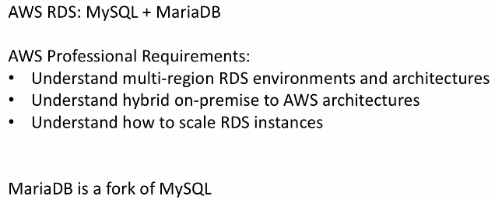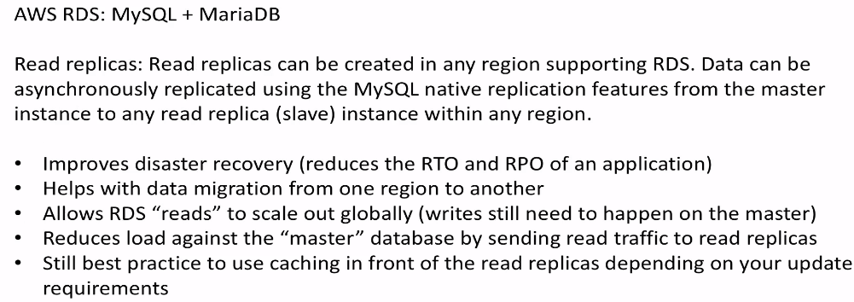

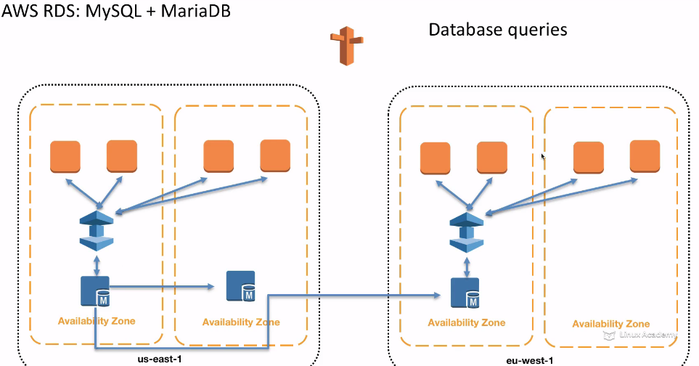

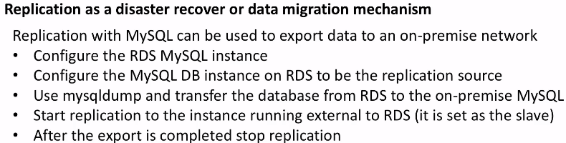

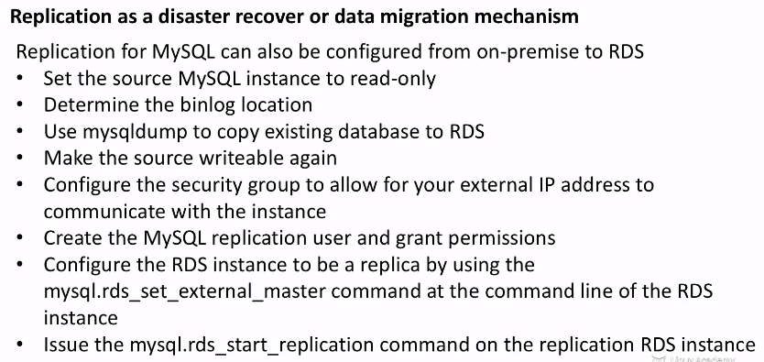

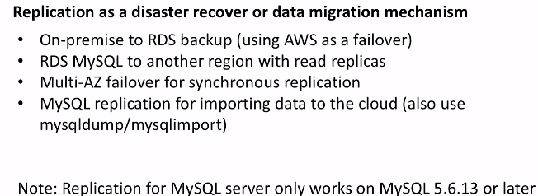o

**65 - RDS - Backups, Multi-AZ & Read Replicas**

